xor logic
true output when the number of true inputs is odd
A. B`+A` .B or (A+B)⋅(A`+B`)

xnor logic
A high output results if both of the inputs to the gate are the same
OR
if the number of true inputs is even
(A`+B)(A+B`) and A.B + A`⋅B`

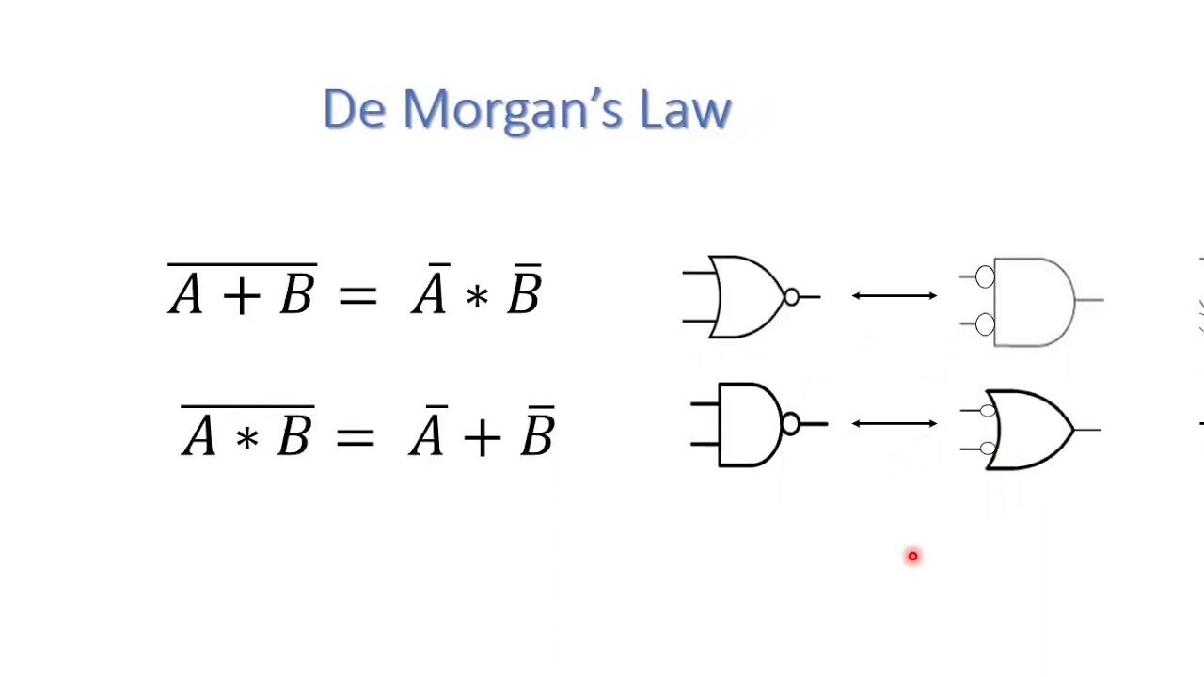
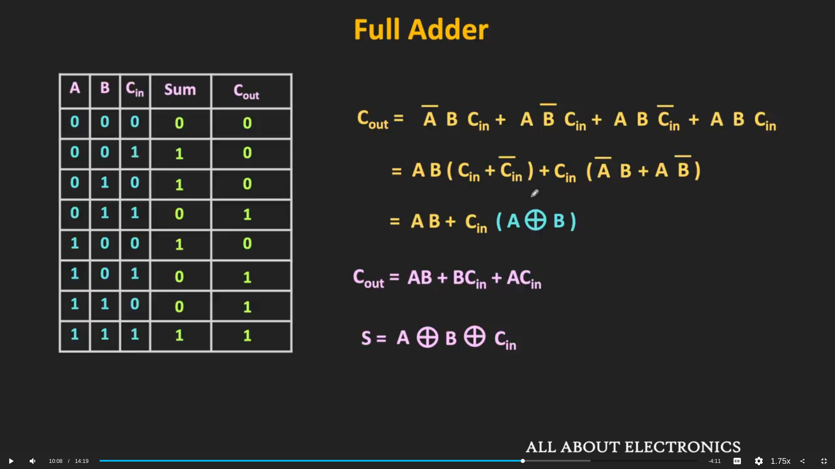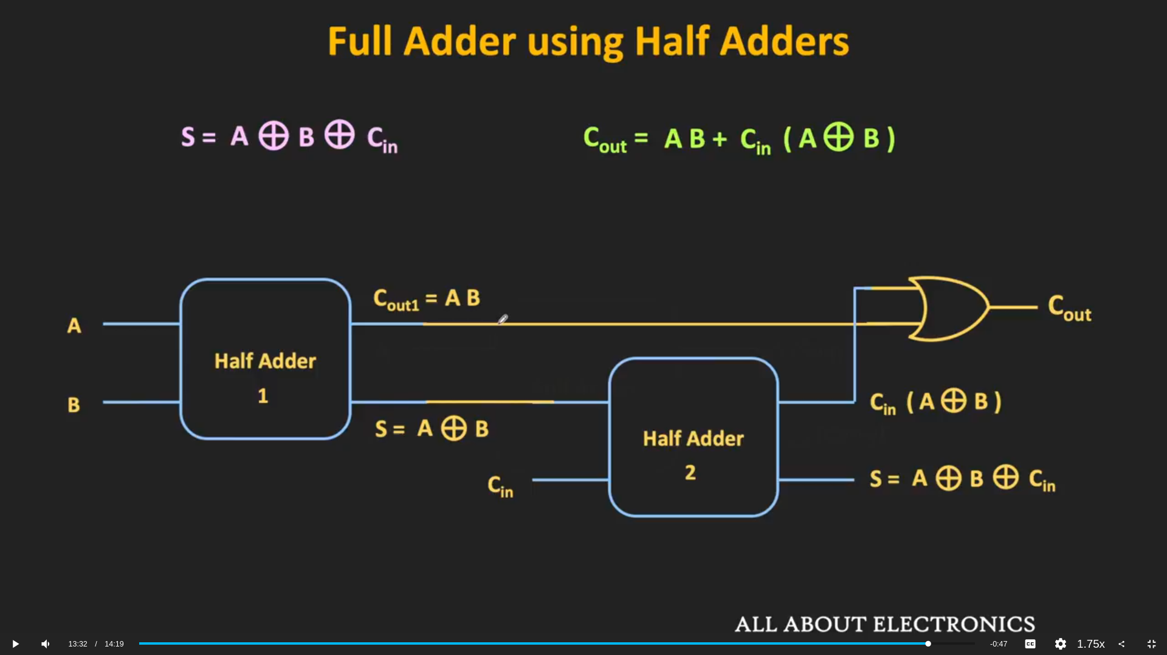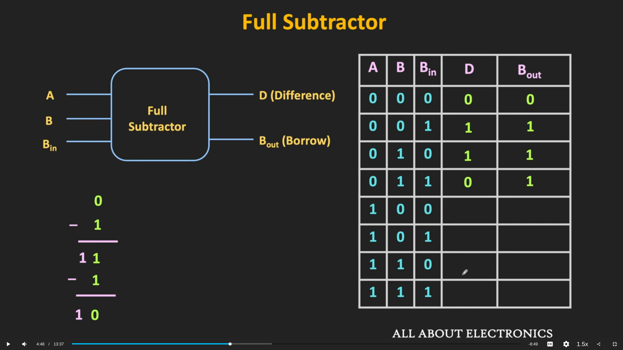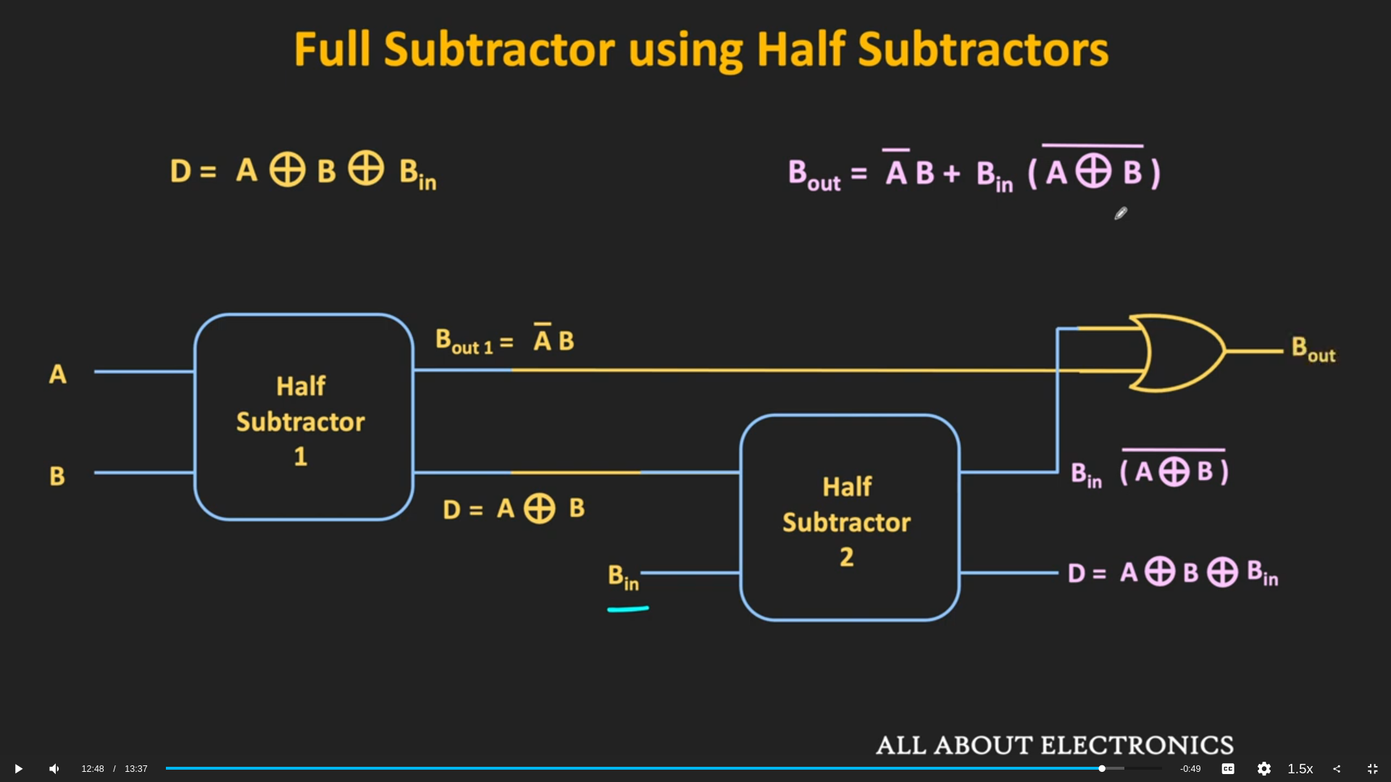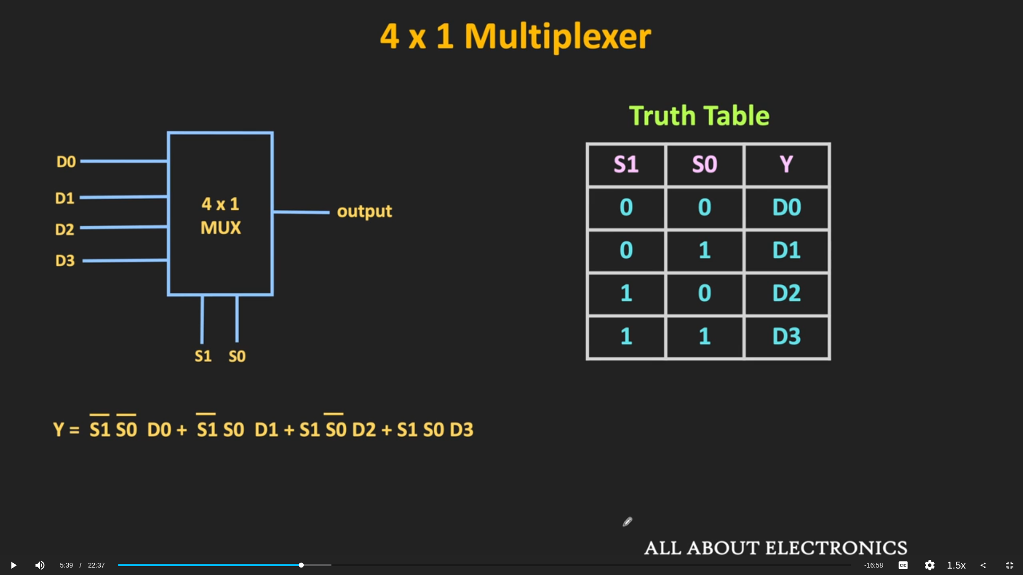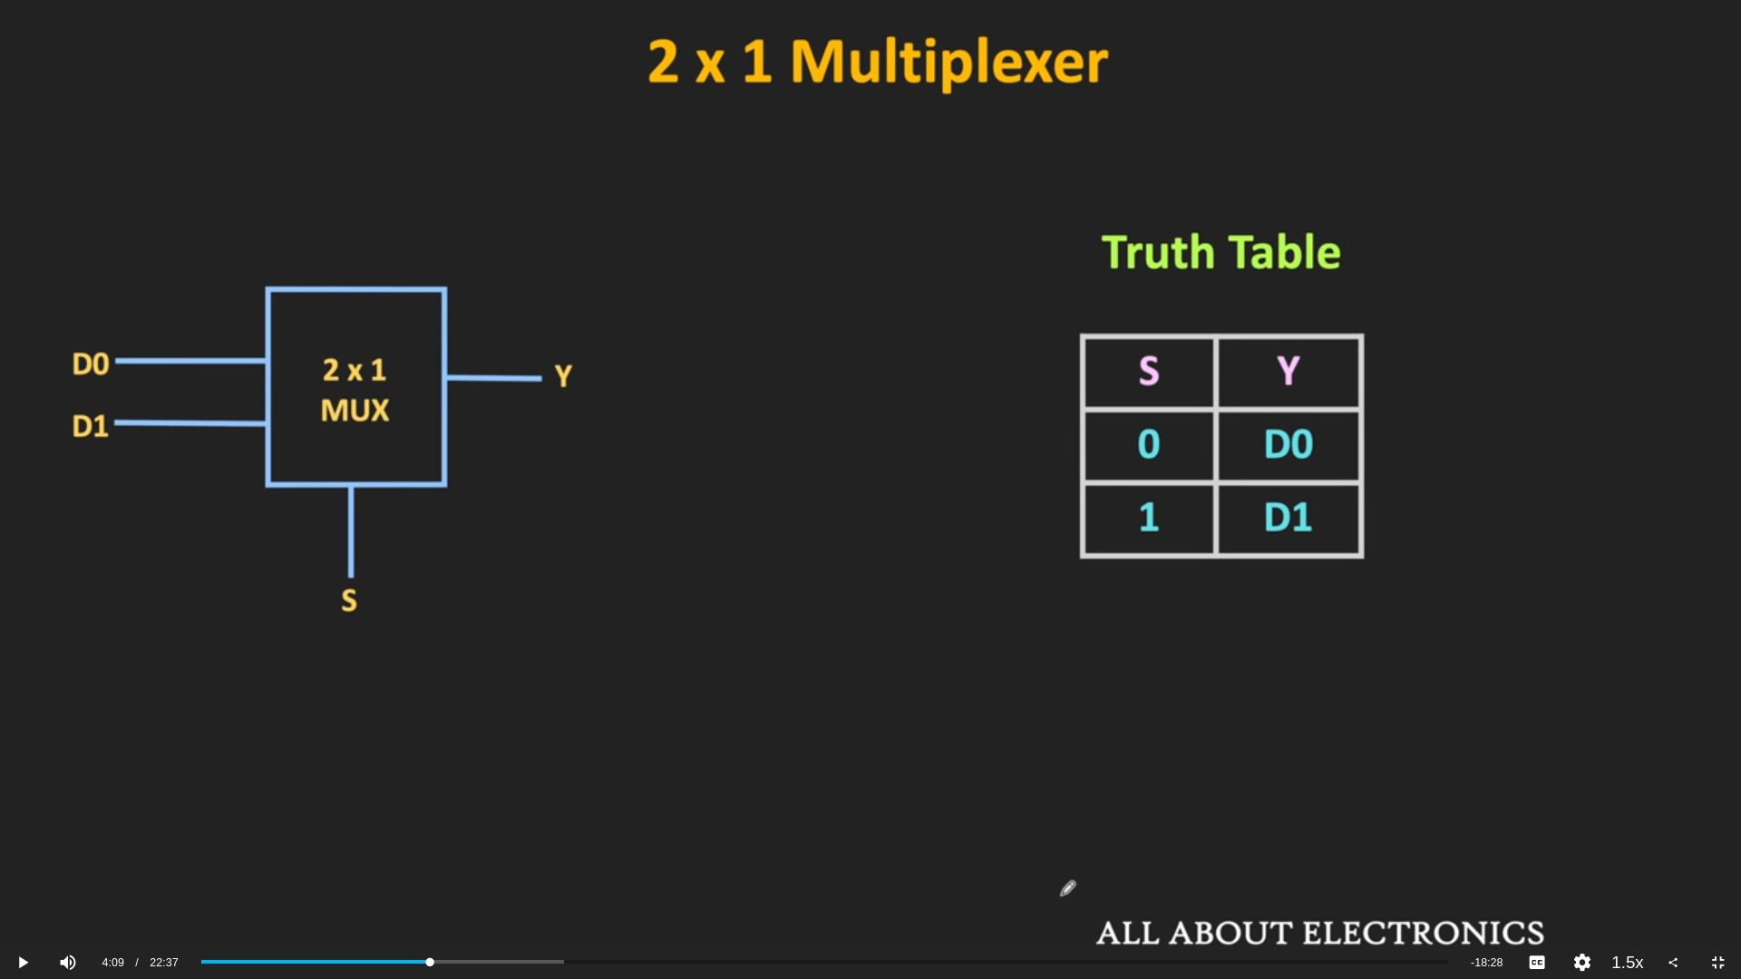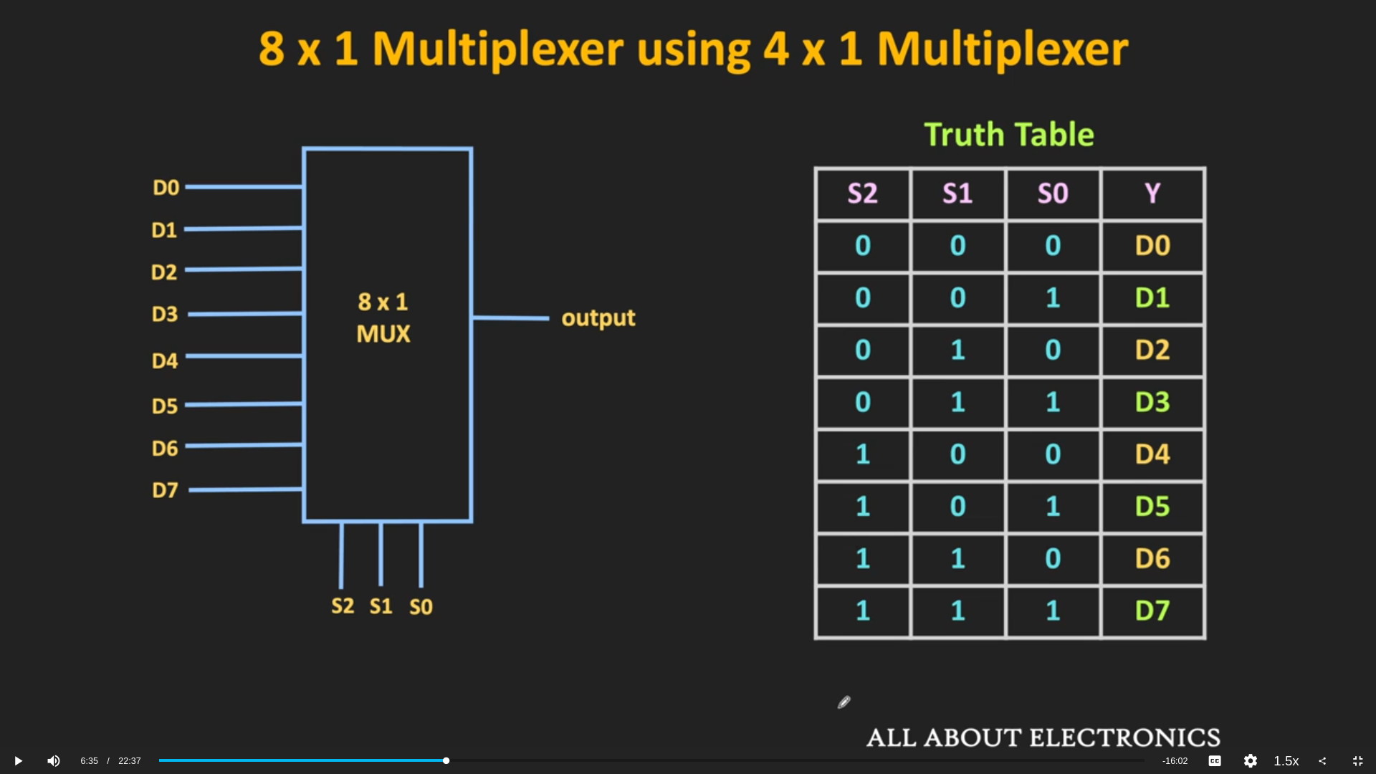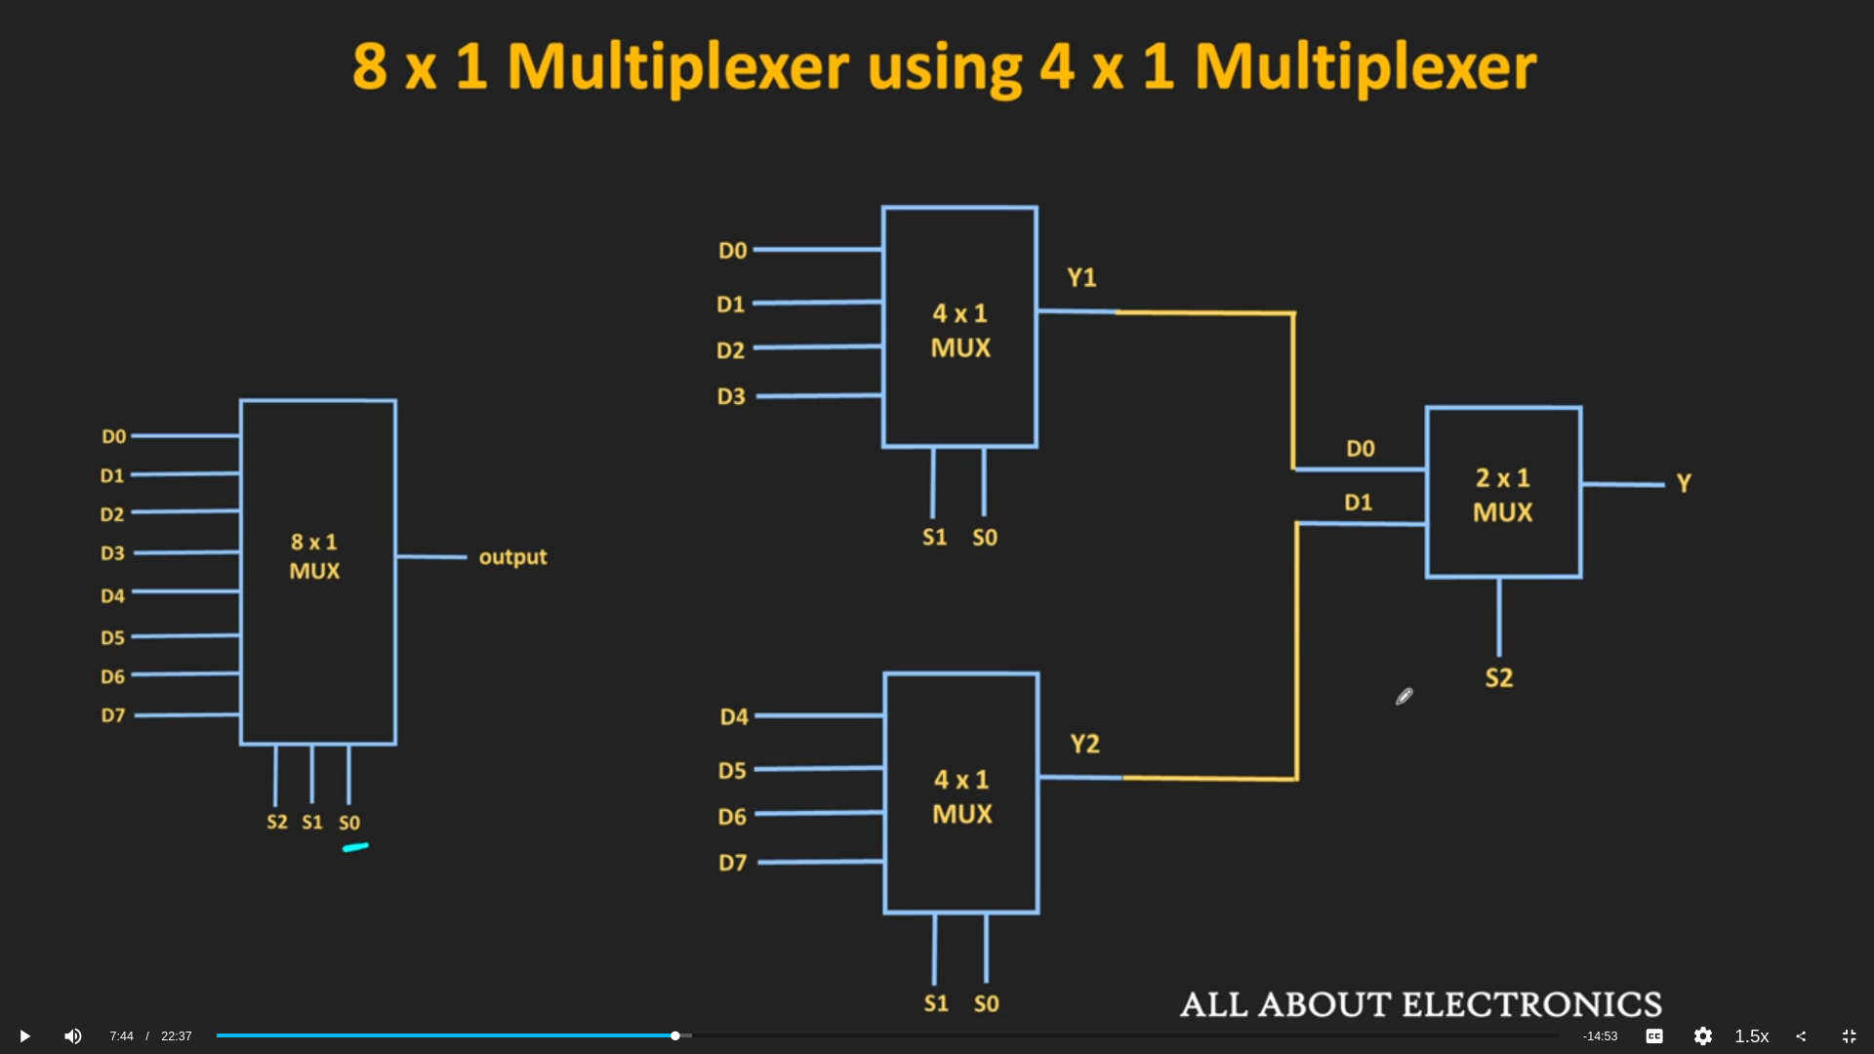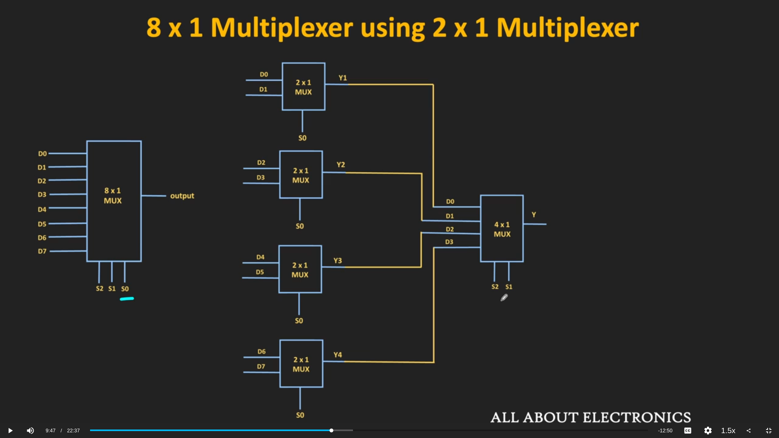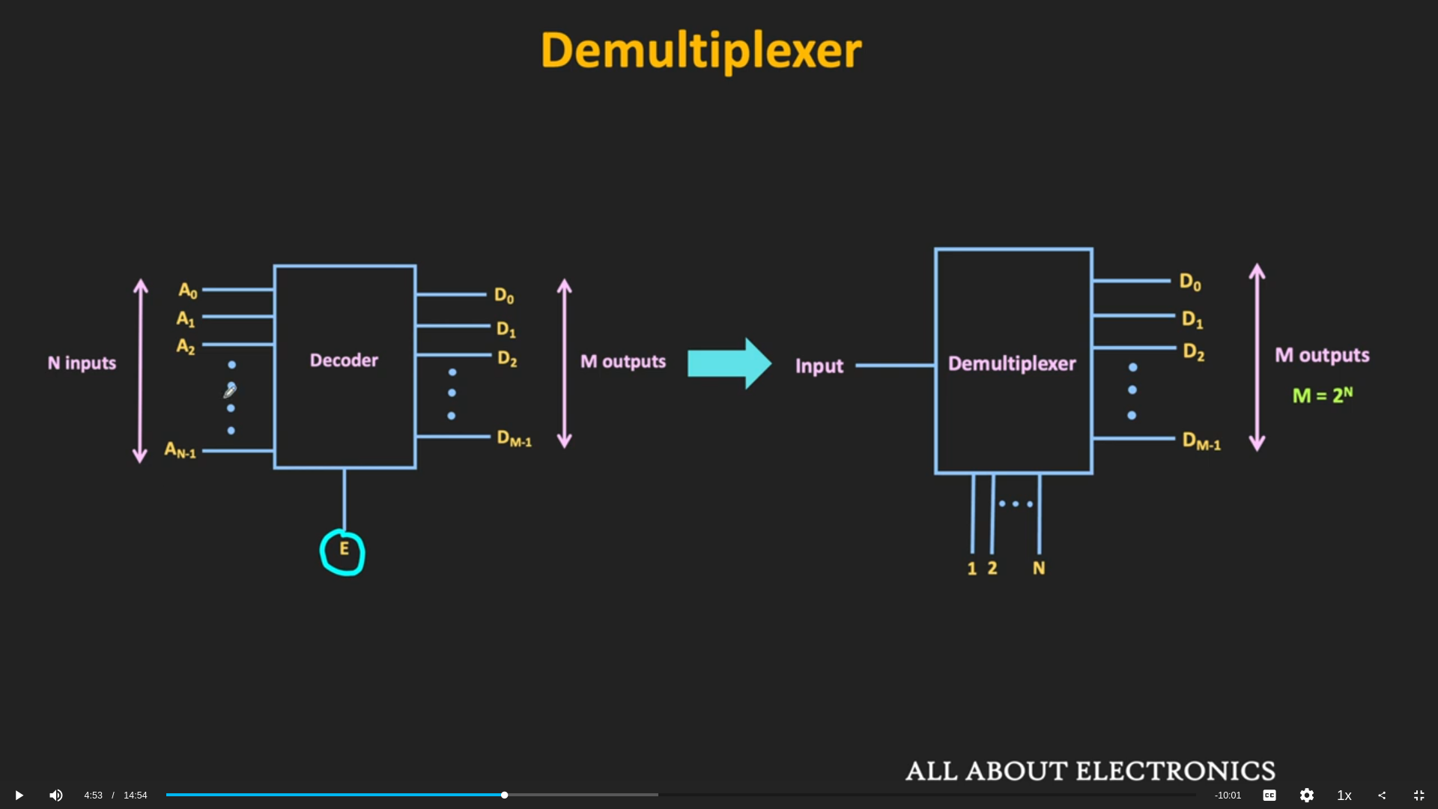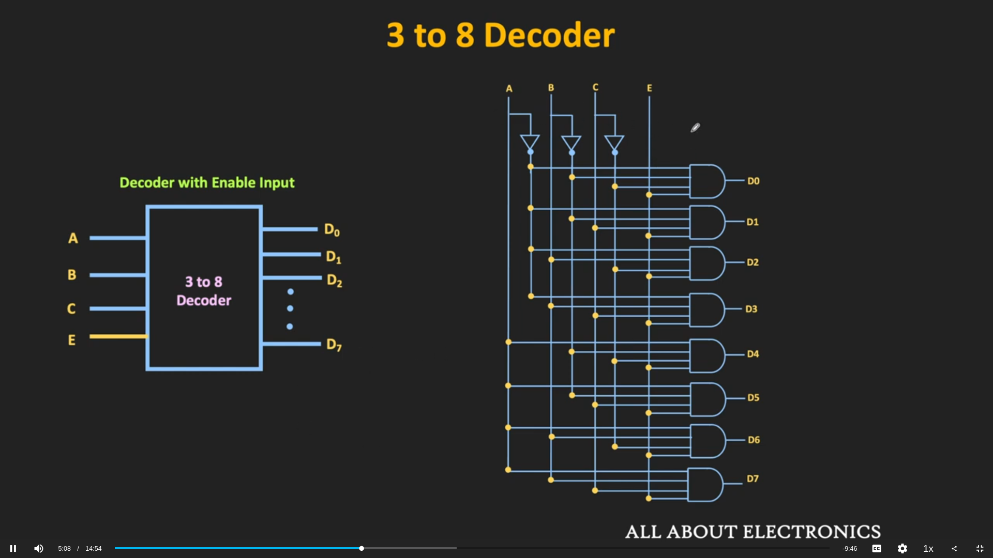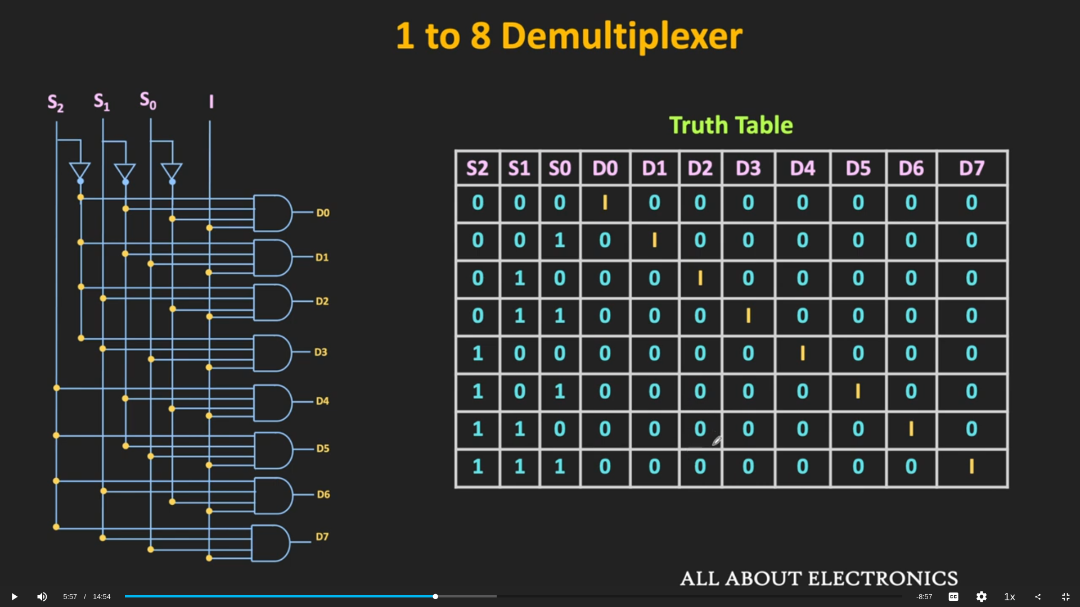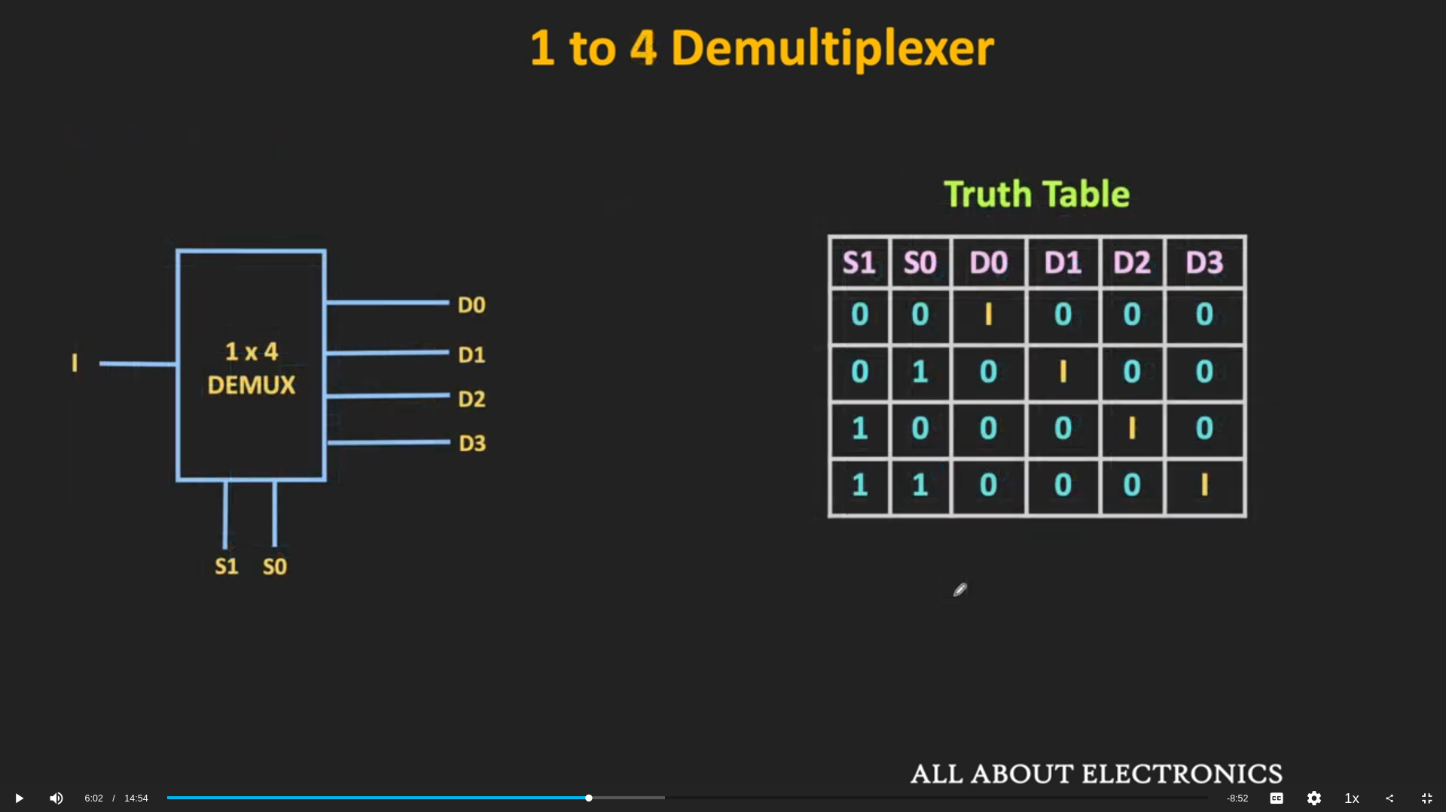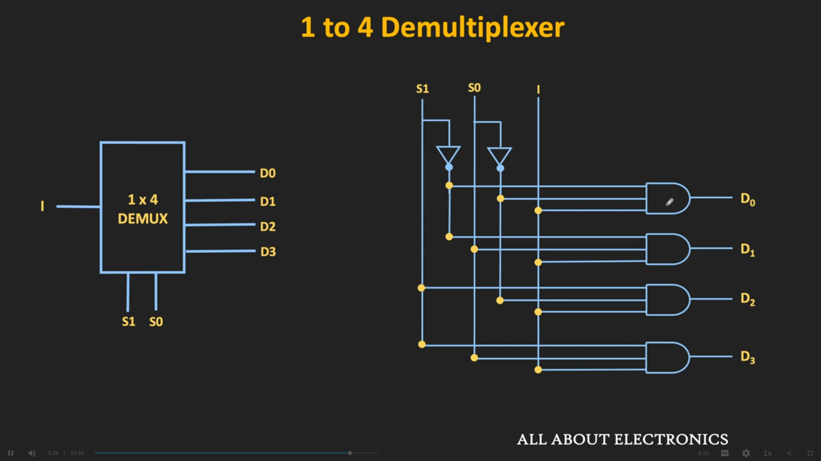
Applications of Decoders
Decoders are used in the cases where an output or a collection of outputs is to be activated only on the occurrence of a particular combination of input codes. Some important applications of decoders are listed below −
- Decoders are used for code conversions.
- Decoders are extensively used in memory systems of computers.
- Decoders are also used for de-multiplexing or data distribution.
- Decoders are also used in data routing applications where very short propagation delay is required.
- Decoder may also be used for timing or sequencing purposes.
- Decoders are also utilized to turn on and off digital devices at a specific time.

Applications of Demultiplexers
Demultiplexer is a crucial combinational logic circuit which is used in a number of applications. Some important uses of demultiplexers are listed below −
- Demultiplexers are used in several input and output devices for data routing.
- Demultiplexers are used in digital control systems to select one signal from a mutual stream of signals.
- Demultiplexers are also employed for data transmission in synchronous systems.
- Demultiplexers are also utilized in data acquisition systems.
- Demultiplexers can be used for generating Boolean functions.
- Demultiplexers can be used in serial to parallel converters.
- Demultiplexers are used for broadcasting of ATM packets.
- Demultiplexers can also be used to design automatic test equipment, etc.
Applications of Multiplexers
The multiplexer is one of the widely combinational logic circuits in digital systems. Some important applications of the multiplexers are listed below.
- Multiplexer is used as data selector device.
- Multiplexers are used in communication systems to increase the efficiency of the system.
- Multiplexers are used in telephone networks for integration of several audio signals on a single transmission line.
- To maintain large amount of data, multiplexers are also used in computer memory systems.
- Multiplexers are also employed in TV broadcasting systems.
- Multiplexers are used in satellite communication and GPS (Global Positioning System).
- Multiplexers are also used in PLC (Programmable Logic Control) systems, etc.

SHIFT REGISTERS
used for * and /
as using multiple adders and subtractors makes the circuit complex
eg: LS = * by 2 and RS = / by 2

FF
edge triggered ff, only work when

